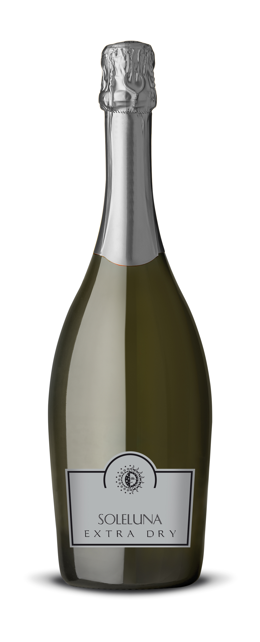
Name 品名： Soleluna Extra Dry 日月-干白汽酒
Wine type 类型： Sparkling dry 绝干型起泡白葡萄酒
Grading 等级: I.G.T. Veneto 维尼托典型产区酒
Grape type 葡萄品种: Prosecco & others 普罗塞科为主
Alcohol 酒精含量： 11.50%Vol
Net content 净含量： 750 ml
Packaging 瓶/箱： 6 bot /box

It is a multivarietal extra dry sparkling wine obtained from Prosecco and other selected wines which add to it some organoleptic peculiarities of Glera and give it some distinctive highlights.

The base wine is obtained with the technique of the fermentation without the skins. This wine is then placed in a closed tank called 'autoclave'. The product is fermented again with selected yeasts at 16°C. After the end of fermentation it is refrigerated at 4°C and left in contact with the yeasts. After the end of the period of ageing the wine is centrifuged and filtered in an isobaric way in another autoclave and then it is bottled.

Straw yellow coloured, it has a fruity, delicate and lightly aromatic fragrance. It has a pleasant acidity and its flavour is lively, piquant, dry and delicate-bodied. It goes very well with shellfishes, light fishes and mollusks. It is excellent also as an aperitif. To be served at 6°C.

晋级是由普罗塞科及其他精选葡萄混合酿制而成的一款多变的干起泡酒，尽显格莱拉葡萄品种的独特风味。

其基酒在酿造的时候剔除了葡萄表皮，在16°C的高压蒸汽灭菌容器内进行发酵，之后在4°C的低温恒压容器内加入精选的酵母进行二次发酵蒸酿，然后再进行一次过滤分离，最后灌瓶上市。

稻黄色的酒体，充满罪人的果香，口感清爽、开胃，适合作为餐前酒，配搭贝类、鱼类、等，在6°C左右饮用效果最佳。

